1. Write SQL query that displays the order_details table and the custom_id field from the orders table corresponding to each record on the order_details table. This must be done using subquery in SELECT statement.
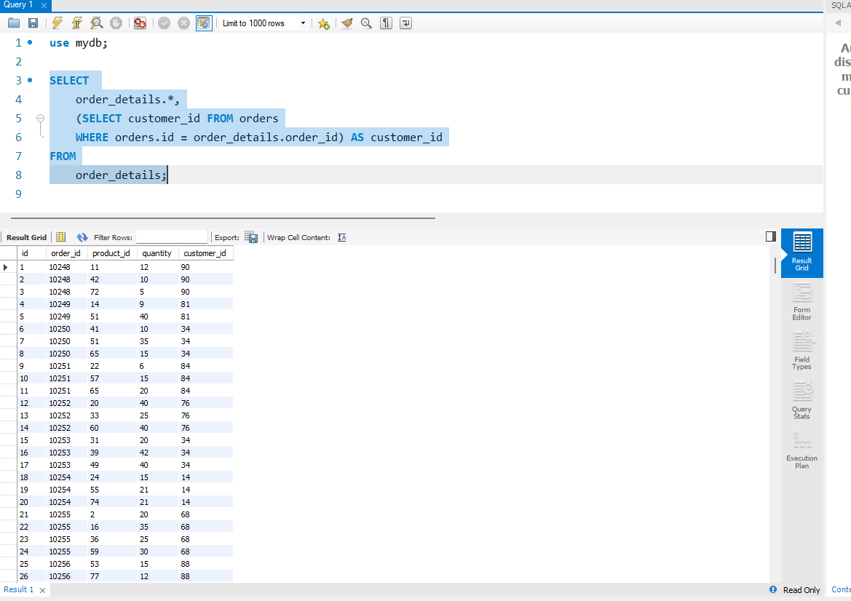
2. Write SQL query that displays the order_details table. Filter the result so that the corresponding record from the orders table satisfies the condition shipper_id=3. This must be done using a subquery in the WHERE clause.
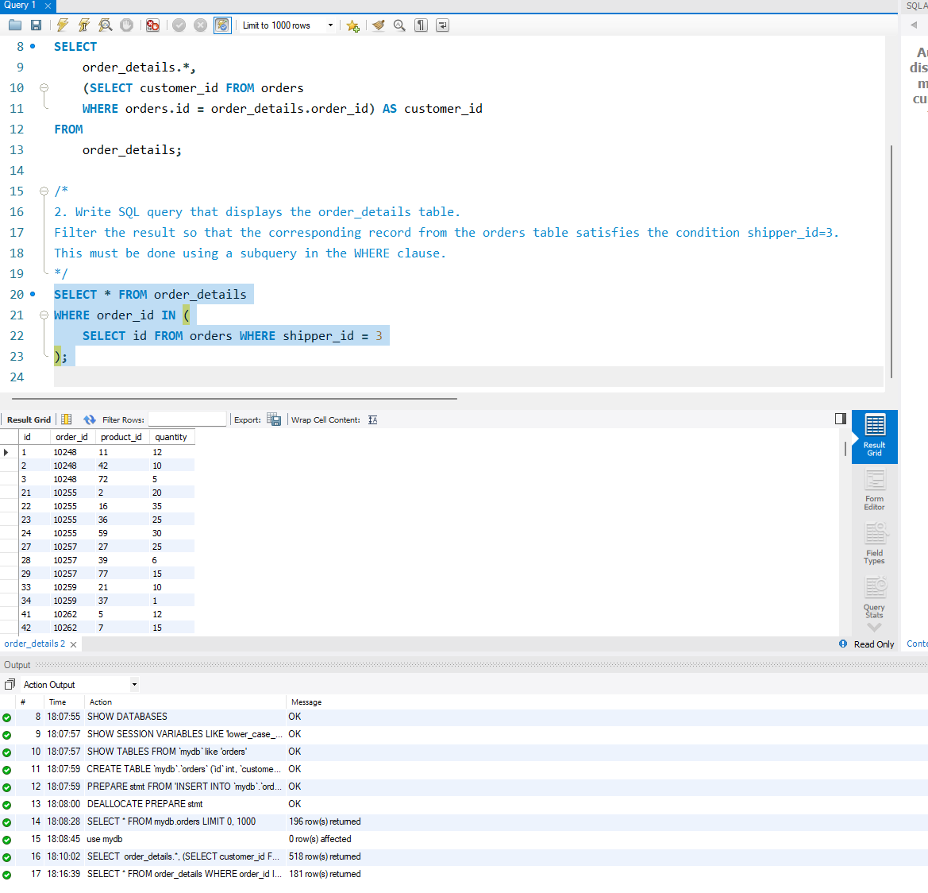
3. Write SQL query in the FROM statement that selects rows satisfying the condition quantity > 10 from the order_details table. For the retrieved data, find the average value of the quantity field, grouping by order_id.
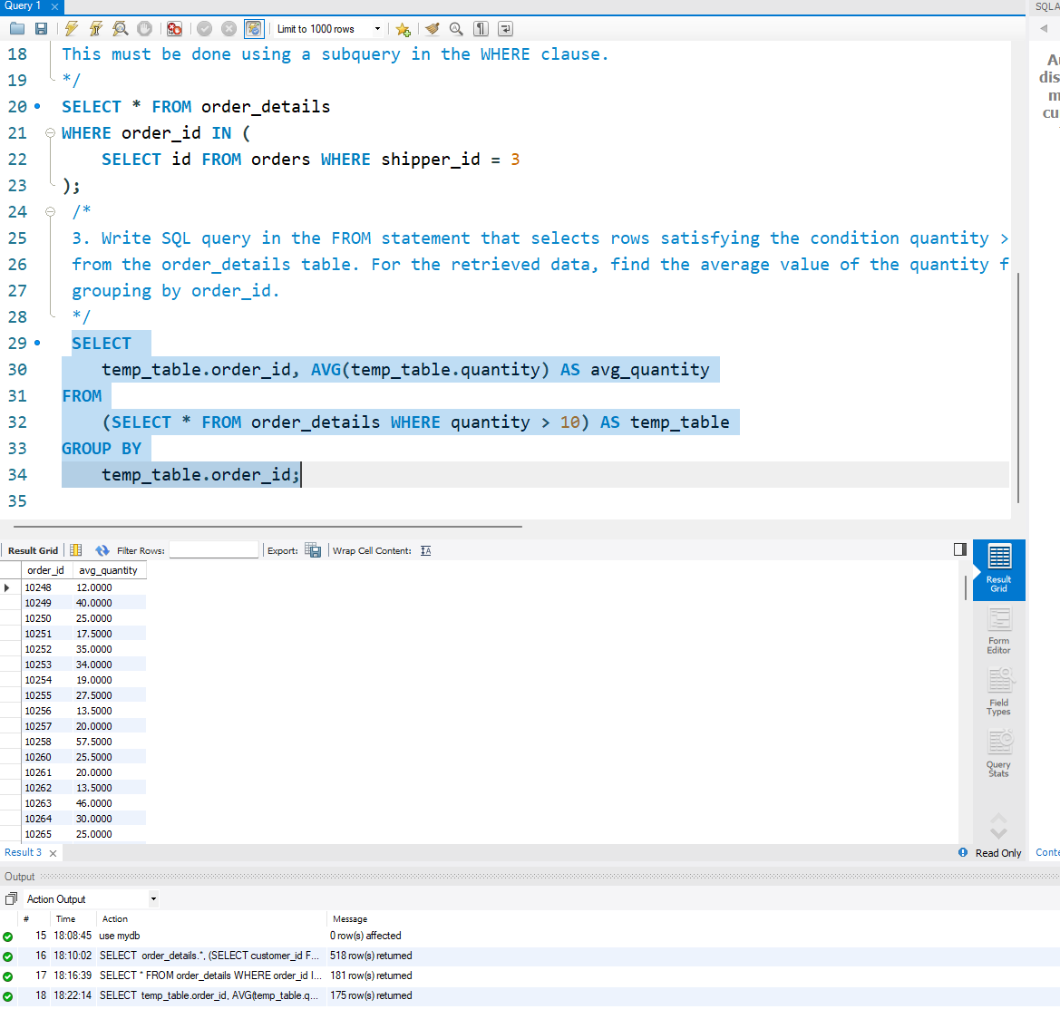
4. Solve task 3 using WITH clause to create a temporary table named temp.
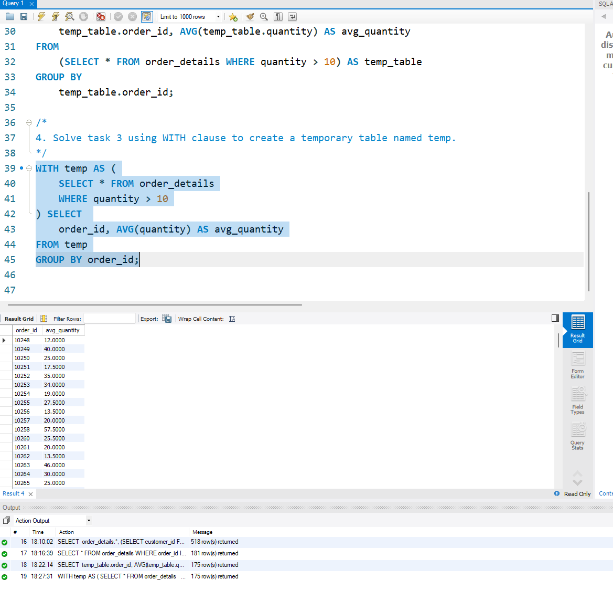
5. Create a function with two parameters that divides the firs parameter by the second. Both parameters and the return value must be type FLOAT. Use the DROP FUNCTION IF EXISTS construct. Apply the function to the quantity attribute of the order_details table. The second parameter can be an attribute number of your choice.
